**Occitanie, Grand-Est and Corsica Regions, France**

Report period 01/10/2023-31/10/2024

**EYWA** (EarlY WArning System for Mosquito-Borne Diseases), a prototype operational system since 2020, addressing the critical public health need for prevention and protection against the Mosquito-Borne Diseases (MBDs).

A game changer in the domain of epidemics that lies under the umbrella of **EuroGEO Action Group** "Earth Observation for Epidemics of Vector-borne Diseases - EO4EViDence"



This monthly Report is produced by the EYWA Project with key contributions in data and scientific expertise from its collaborating partner EID Méditerranée.

**Contents**

**INTRODUCTION** **4**

**PREDICTIVE MODELS** **6**

**MAMOTH – Mosquitoes’ Abundance model** **6**

*A. Culex* mosquitoes’ abundance prediction 6

B. Aedes albopictus mosquitoes’ abundance prediction  8

# Introduction

More than 80% of the global population lives in areas at risk of at least one major Vector-Borne Disease (VBD), with more than 700.000 deaths at a global scale. Mosquitoes are the protagonists of these vectors, carrying pathogens and transmitting various diseases to living beings and especially humans. Although specific actions and practices were adopted to control these diseases in Europe in the past decades, the re-emergence of outbreaks is just around the corner. Europe is experiencing an increasing number of human cases of Mosquito-Borne Diseases (MBD) in the last two decades, such as West Nile Virus (WVN), Malaria, Chikungunya, Dengue and Zika, both imported and indigenous, which demonstrates that Europe is not immune from MBD.

In France, the entomological situation was under control for almost 45 years. After 2000, West Nile Virus (WNV) cases, mainly in equids, started to occur in southern France. In 2018, a never-seen before outbreak of WNV Lineage 2 occurred. In addition to Culex mosquitoes and WNV, Aedes albopictus became established in France in 2004 and has since spread throughout a large part of the country. France has experienced several events of autochthonous Dengue and Chikungunya transmission between 2010 and 2018. Other emerging viruses may also prove to be a challenge for the country’s preparedness and response systems, something already observed with the Zika virus when cases were reported in France in 2016 (Table 1).

*Table 1.* WNV, Dengue, Zika and Chikungunya infection cases in France over the years 2008-2023 (source: ECDC).

|  |  |  |  |  |  |  |  |  |  |  |  |  |  |  |  |  |
| --- | --- | --- | --- | --- | --- | --- | --- | --- | --- | --- | --- | --- | --- | --- | --- | --- |
| Year | 2008 | 2009 | 2010 | 2011 | 2012 | 2013 | 2014 | 2015 | 2016 | 2017 | 2018 | 2019 | 2020 | 2021 | 2022 | 2023 |
| WNV infection cases | 0 | 1 | 0 | 0 | 69 | 302 | 76 | 28 | 41 | 49 | 415 | 32 | 0 | 3 | 4 | 43 |
| Dengue | 56 | 64 | 596 | 55 | 152 | 456 | 367 | 285 | 373 | 266 | 331 | 904 | 12 | 231 | 65 |  |
| Zika |  |  |  |  |  |  |  |  | 1141 | 28 | 10 | 16 | 0 | 231 |  |  |
| Chikungunya | 1 | 13 | 44 | 12 | 11 | 12 | 788 | 68 | 42 | 35 | 16 | 108 | 0 | 4 |  |  |

EYWA is a revolutionary, scalable and sustainable EarlY WArning System for Mosquito-Borne Diseases and a game changer in the domain of epidemics. It was developed under the flag of EuroGEO Action Group “Earth Observation for Epidemics of Vector-Borne Diseases-EO4EViDence".

The system is based on a plethora of satellite Earth Observation (environmental, meteorological, geomorphological etc.), in-situ entomological networks, epidemiological and crowdsourcing data. These Big Data are combined with mathematical modelling, artificial intelligence, and state-of-the-art technological tools. The system’s models provide mosquitoes’ population abundance and human cases risk predictions, at trap, settlement and municipality level accordingly.

In recognition of the advances made by the system in providing early warning, EYWA was awarded the 1st EIC Horizon Prize on Early Warning for Epidemics.

EYWA was pre-operationally tested in Grand-Est and Corsica regions in France, forecasting *Aedes albopictus* mosquito populations, during the mosquito season in 2020, and provided operational predictions for the years 2021, 2022 and 2023.

EYWA continues its operation in 2024, informing the local authorities and decision makers about *Aedes albopictus* and *Culex* mosquitoes’ abundance at the traps sites in Grand-Est and Corsica, and Occitanie regions respectively.

# Predictive models

The results of the “MAMOTH” data-driven mosquitoes’ abundance model for the period **08/10/2024 – 23/10/2024** are presented in the following sections.

## MAMOTH – Mosquitoes’ Abundance model

The “MAMOTH” data-driven mosquitoes’ abundance predictive model has been in operational use since 2020. The model is able to predict the risk classes of mosquitoes’ population.

For each entomological record, the respective EO environmental and meteorological data (NDVI, NDWI, NDMI, NDBI, Land Surface Temperature, rainfall and wind), and geomorphological data (land use, aspect, elevation etc.) have been extracted from Sentinel-2, Landsat-7 & -8, MODIS, and ERA-5 to create the comprehensive feature space.

The abundance of the mosquitoes has been classified into 10 risk classes starting from 0 indicating the lower class of mosquito presence reaching the higher class 9, with each one having equal probability of selection. A Xgboost mode; is trained for this task, and a certain pipeline is followed. The multi-source dataset mentioned above, underwent spatial and temporal integration, as well as feature engineering that has been applied to further extend the initial dataset through new informative features that capture the spatio-temporal dependencies of the problem. Through an automated process the model can tune its own parameters and select the most important features out of a pool of potential features in each case in order to better fit the dataset, and achieve higher prediction performance.

### *A. Culex* mosquitoes’ abundance prediction

The forecast model is based on time series entomological data for the period of 2007-2022. The dataset has been gathered from CO2 and gravid traps, which were used to lure and sample adult mosquitoes from 36 stations distributed among the Occitanie region. The data consist of 8617 records and represent the number of mosquitoes and the date of trap placement.

#### Risk classes

Table 2 shows the classes of the mosquito abundance and the bounds (range) of mosquito’ numbers per each class.

Table 2: Bounds of C*ulex mosquito risk classes.*

|  |  |  |
| --- | --- | --- |
| Class | Number of mosquitoes | Risk class |
| 0 | 0 - 1 | low |
| 1 | 2 - 4 |
| 2 | 5 - 8 | medium |
| 3 | 9 - 11 |
| 4 | 12 - 16 |
| 5 | 17 - 23 |
| 6 | 24 - 30 | high |
| 7 | 31 - 60 |
| 8 | 61 - 206 |
| 9 | > 206 |

#### Reliability of the model

The model has been trained on historical data for the period of 2010 to 2022. The trained model outperforms statistically with an expected mean absolute error of **1.82** classes between the actual and the predictive value. Furthermore, the model proves its robustness by capturing the low, medium, and high-risk classes of the mosquito population with a predictive accuracy of 84**%.**

#### Prediction

The predictions of the model are presented in the map of Figure 1, which depicts the predicted trap – stations for October 2024 in the Occitanie region ranging from traps colored in blue, stations that the model predicts lower risk class of the Culex population, to traps colored in red indicating stations with prediction of higher risk class in mosquito abundance. The predictions for October showed that the stations in the Occitanie region will fall into the **low, medium & high risk classes** ranging from risk class 0 to risk class 8. In further detail:

* 2924 stations were predicted with risk class 0 - 1 indicating low abundance of mosquitoes (0-4).
* 3540 stations were predicted with risk classes 2 - 5 indicating medium abundance of mosquitoes (5-23).
* 84 station was predicted with risk class 6-8 indicating high abundance of mosquitoes (24-206).

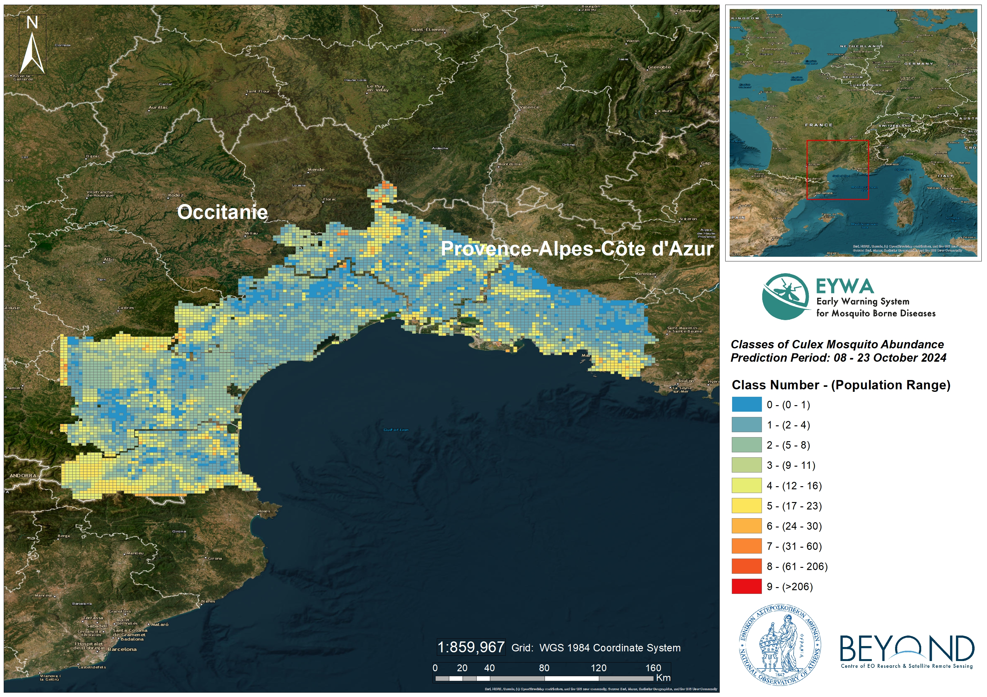

*Figure 1. Culex mosquito abundance at 2x2 km grid for October 2024.*

### B. Aedes albopictus mosquitoes’ abundance prediction

The forecast model is based on time series entomological data for the period of 2017-2022. The dataset has been gathered from CO2 and gravid traps, which were used to lure and sample mosquitoes’ eggs from 107 stations distributed among the Grand-Est and Corsica regions. The data consist of 5878 records and represent the number of mosquitoes’ eggs and the date of trap placement.

#### Risk classes

Table 3 shows the classes of the *Aedes albopictus* mosquitoes’ eggs abundance and the bounds (range) of mosquitoes’ eggs numbers per class.

*Table 3. Bound of Aedes albopictus mosquitoes’ eggs risk classes.*

|  |  |  |
| --- | --- | --- |
| Class | Number of mosquito eggs | Risk class |
| 0 | 0 - 1 | low |
| 1 | 2 - 6 |
| 2 | 7 - 16 | medium |
| 3 | 17 - 30 |
| 4 | 31 - 51 |
| 5 | 52 - 79 |
| 6 | 80 - 130 | high |
| 7 | 131 - 210 |
| 8 | 211 - 400 |
| 9 | > 400 |

#### Reliability of the model

The model has been trained and tested on 10-fold validation data. The trained model outperforms statistically with an expected mean absolute error of **0.59** classes between the actual and the predictive value. Furthermore, the model proves its robustness by capturing the low, medium and high-risk classes of mosquitoes’ eggs population with a predictive accuracy of **95%.**

#### Prediction

The predictions of the model are presented in the map of Figure 2 and Figure 3, which depict the predicted trap – stations for October 2024 in the Grand-Est and Corsica regions ranging from traps colored in blue, stations that the model predicts lower risk class of the *Aedes albopictus* population, to traps colored in red indicating stations with prediction of higher risk class in mosquitoes’ eggs abundance. The predictions for October showed that the stations in the Grand-Est and Corsica region will fall into **the low, medium risk class** ranging from risk class 0 to risk class 9. In further detail:

* 2532 stations were predicted with risk classes 0 & 1 indicating low abundance of mosquitoes’ eggs (0-6).
* 717 stations were predicted with risk classes 2 - 5 indicating medium abundance of mosquitoes’ eggs (7-79).
* 1139 stations were predicted with risk classes 6-8 indicating medium abundance of mosquitoes’ eggs (80-400).

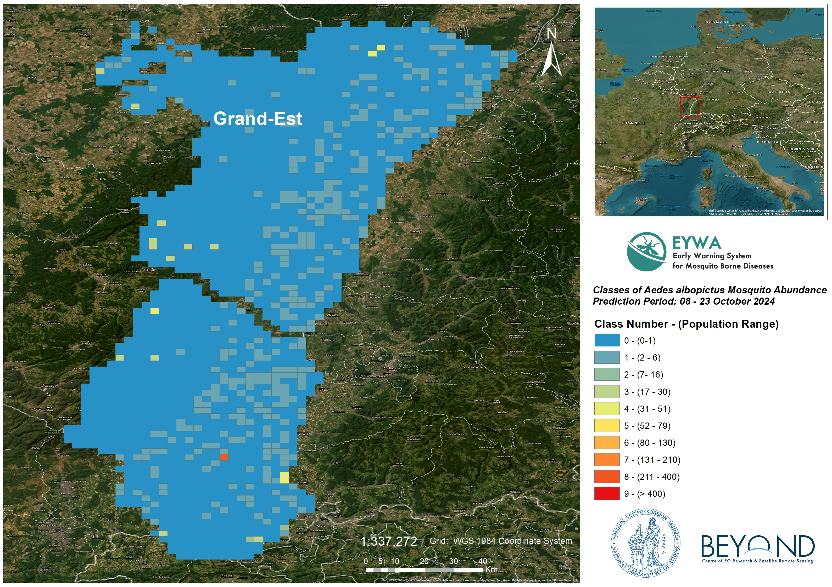

*Figure 2. Aedes albopictus mosquitoes’ eggs abundance at 2x2 km grid in Grand-Est for October 2024.*

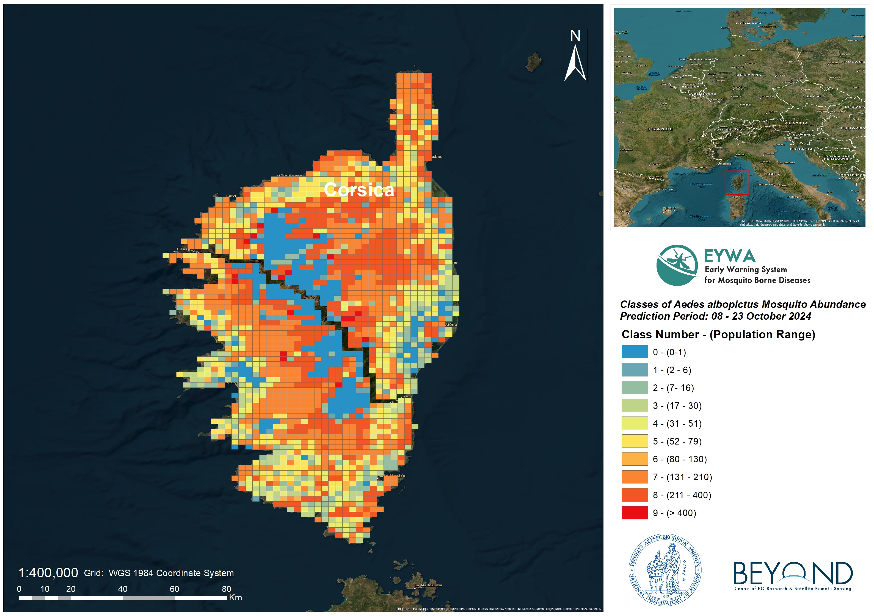

*Figure 3. Aedes albopictus mosquitoes’ eggs abundance at 2x2 km grid in Corsica for October 2024.*

#### Intention of the predictions

This Report’s predictions aim to assist National Public Health Authorities and relevant decision makers in:

* organization, resources allocation and strategic design of their mosquito control actions.
* intensification and targeted implementation of entomological and epidemiological surveillance actions.
* information, education and training of citizens on individual mosquito protective measures and actions.

For further information and feedback for the usefulness of the predictions, please contact us at kontoes@noa.gr and +30 210-3490012 (BEYOND Centre of Excellence / National Observatory of Athens).

On behalf of the EYWA project team:

|  |  |  |
| --- | --- | --- |
| **EYWA Project Coordinator**  Dr. Haris Kontoes  Research Director of BEYOND/ NOA  Coordinator of EuroGEO Action Group for Epidemics  Tel: [0030-2103490012](tel:0030-2103490088)  email: kontoes@noa.gr |  | **Collaborating partners’ institutions in France**  EID Méditerranée |